Experiment – 15
Creation of a VM Snapshot and Restoration of a Previous Version Using VMware
Workstation
Aim
To create a snapshot of a virtual machine using VMware Workstation and test it by restoring the previous state or loading a cloned virtual machine.
Procedure
- Open VMware Workstation on the Windows host operating system.
- Select the Ubuntu virtual machine and power it on.
- Wait for the guest operating system to start successfully.
- Click VM → Snapshot → Take Snapshot to save the current state of the virtual machine.
- Enter a snapshot name, such as Ubuntu_Before_Changes, and provide a description if required.
- Click Take Snapshot to create the snapshot.
- Make changes to the virtual machine, such as creating a new file or modifying an existing file.
- Shut down the virtual machine and open VM → Snapshot → Snapshot Manager.
- Select the previously created snapshot and click Go To to restore the saved state.
- Confirm the operation if prompted and start the virtual machine again.
- Verify that the virtual machine has returned to its previous state and that the changes made after the snapshot are no longer present.
- If cloning is required, use the Clone option, if available, to create a separate copy of the virtual machine and verify that it starts successfully.

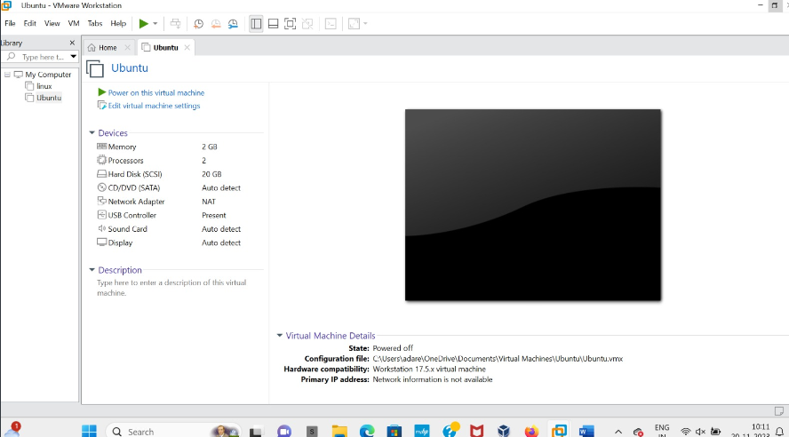

Output:

Result

Thus, a snapshot of the virtual machine was created using VMware Workstation, and the
previous state was restored and tested successfully.

